# Dependency

* 1. gson-2.3.1.jar

This library is used to convert json format data. It is used when implementing the auto complete function for search.

1. Put it into ‘lib’ folder of apache server. For example, ” C:\apache-tomcat-8.5.0\lib”.
2. Add “C:\apache-tomcat-8.5.0\lib\gson-2.3.1.jar” to environment variable ‘CLASSPATH’.
   1. jstl-1.2.jar

# Pages

* 1. Home Page



* 1. Consoles

1. When visit this page through the top menu, all consoles will be displayed.
2. When visit through the side bar, only the consoles of that brand will be displayed.

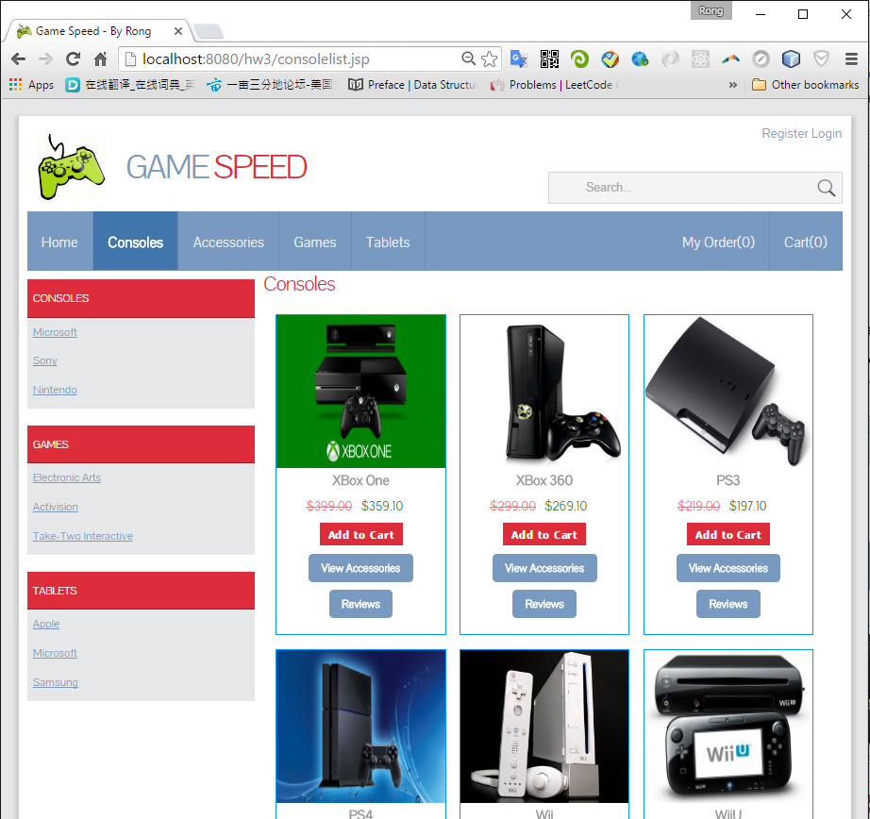Accessories

1. When visit this page through the top menu, all accessories will be displayed.
2. When visit through the side bar, only the accessories with that console will be displayed.

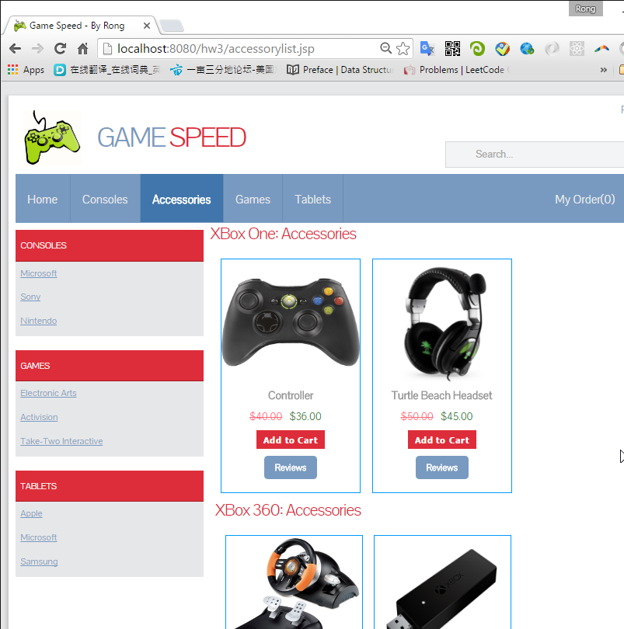

* 1. Games

1. When visit this page through the top menu, all games will be displayed.
2. When visit through the side bar, only the games of that maker will be displayed.

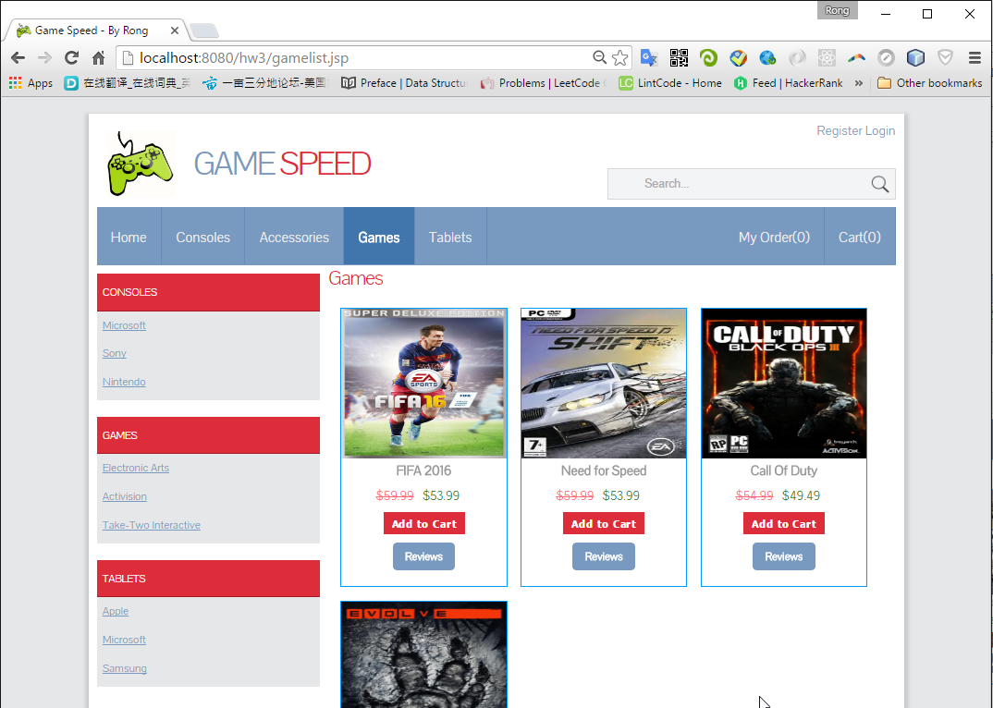

* 1. Tablets

1. When visit this page through the top menu, all tablets will be displayed.
2. When visit through the side bar, only the tablets of that brand will be displayed.

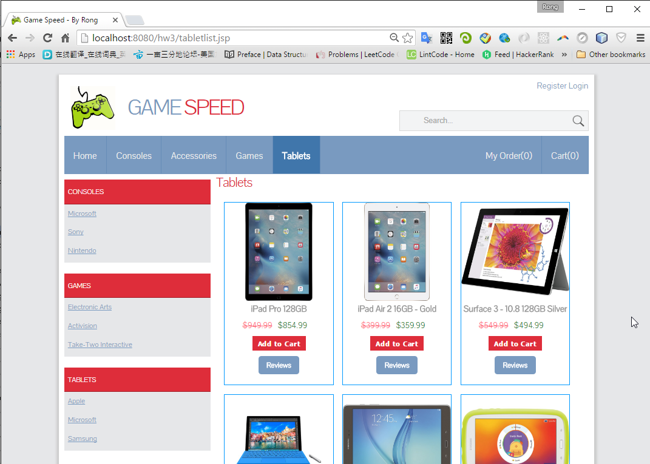

# General Functions

* 1. Search Products

1. You can search any product, including Console, Accessory, Game and Tablet.

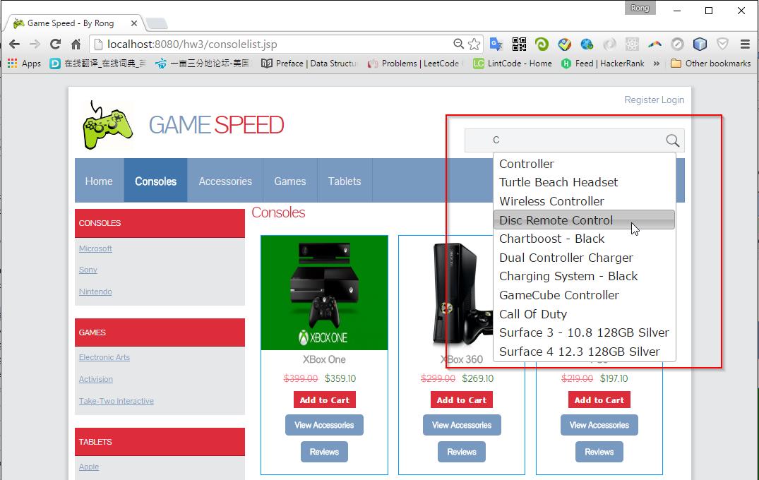

1. Auto complete is implemented.

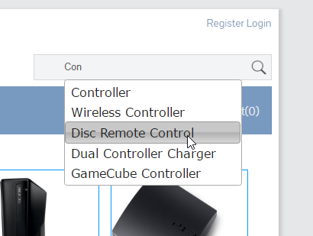

1. Search Results.



* 1. Review

1. You can check the review for any product.

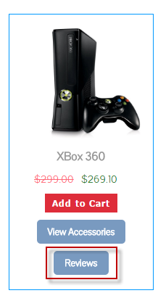

1. All of the review comments are displayed in the bottom of the page.

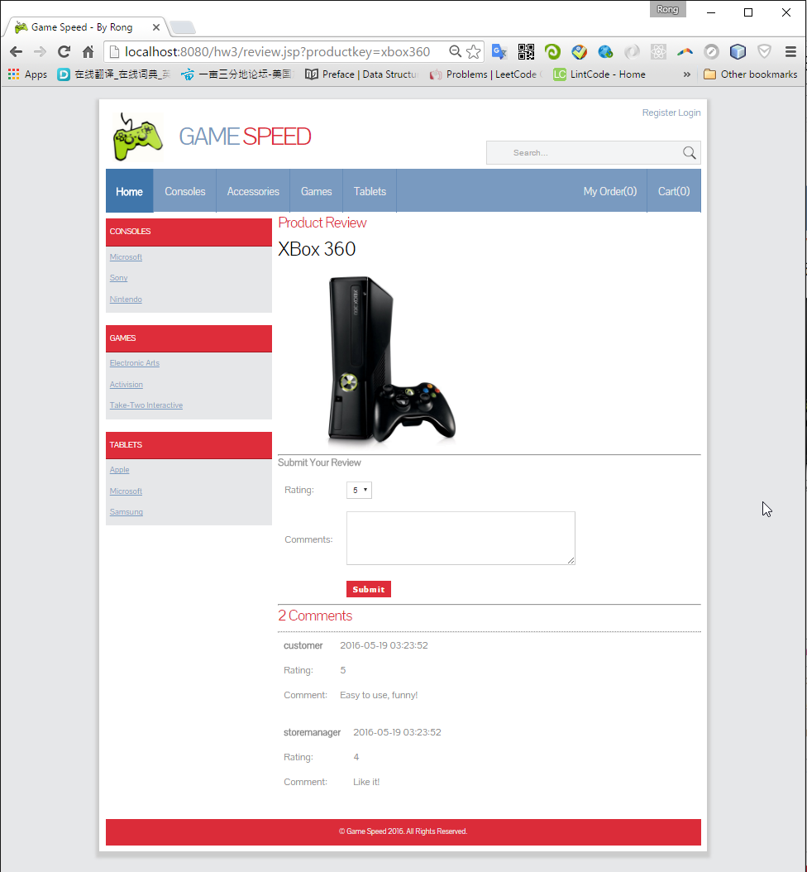

1. After login, you can submit new comment to product.
   1. Register

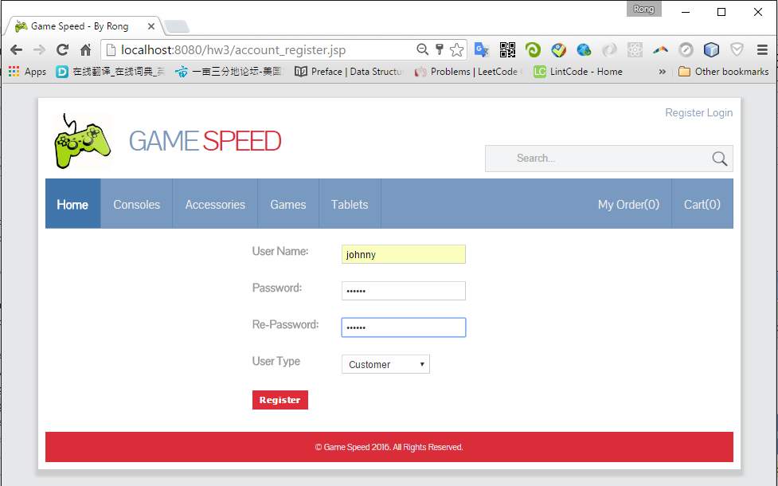

* 1. Login

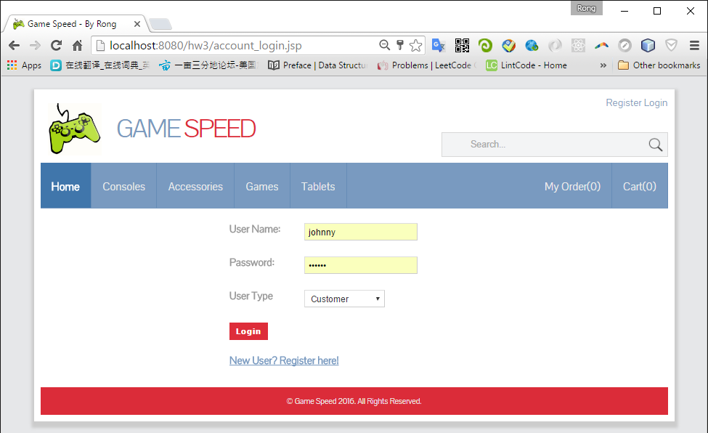

# Role-Based Functions

1. All the role based functions are available only for the login user. You will get error message if you try to access unauthorized pages/functions.

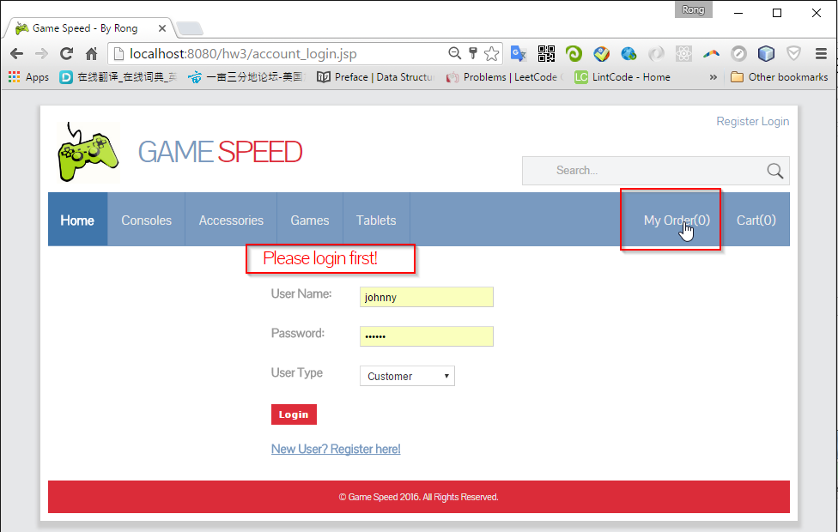

1. After successfully login, the buttons at the top right of the webpage are changed. You username will be displayed and you can logout.
2. The original and discounted price are both shown for each product. Click ‘Add to cart’ button to add the current item to your cart

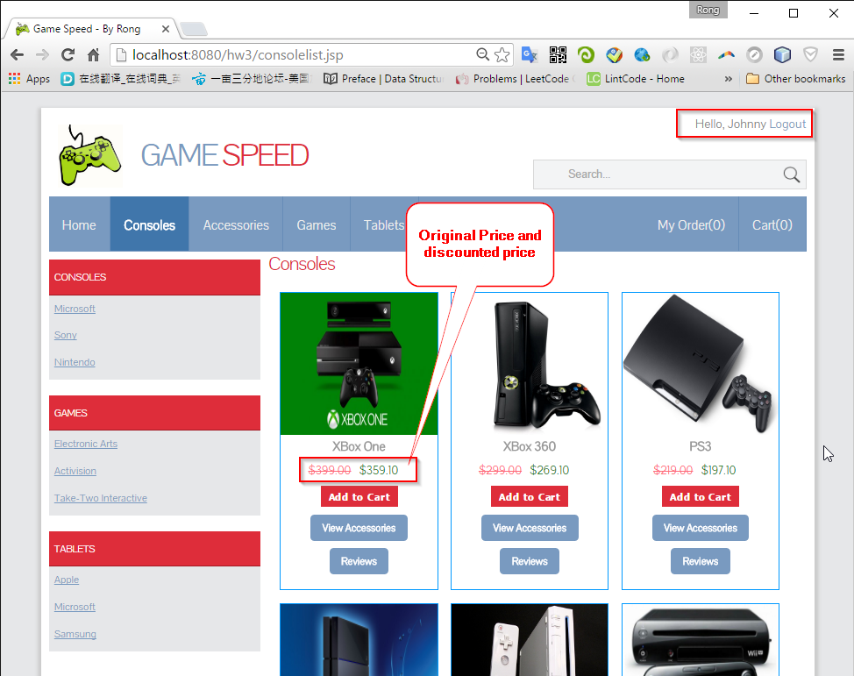

* 1. Customer

Customer can purchase products, add item to cart and place order finally.

* + 1. Cart

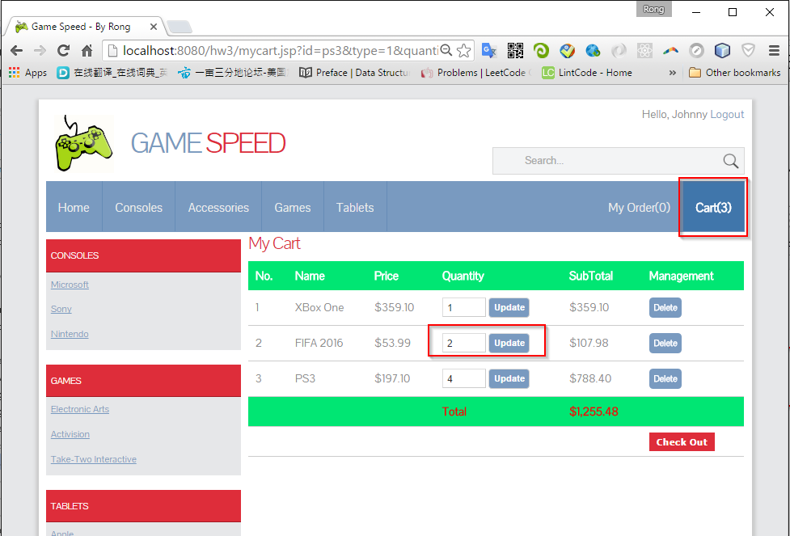

1. You can choose any product(console, accessory, game or tablet) added to your cart.
2. If any item added/removed from the cart, ‘Cart(n)’ will be refreshed immediately.
3. In the cart, you can update the quantity.
4. You can also remove the item.
5. The price is the discounted price.
6. The SubTotal shows the amount for each item cost(quantity may be larger than 1).
7. The Total shows the total amount cost of all items in this cart.
   * 1. Checkout
8. The credit card number must be 16 digits length.

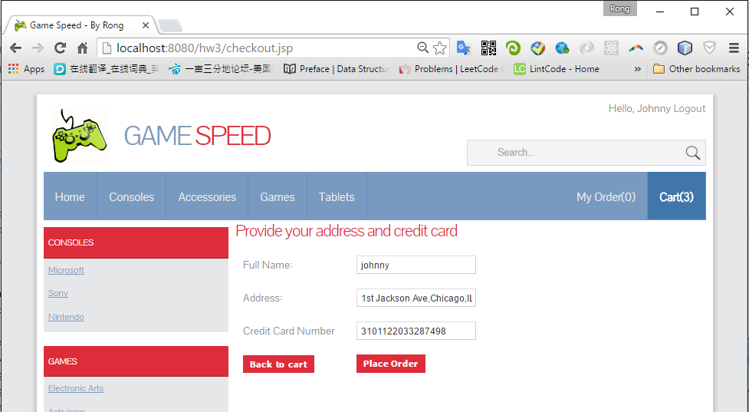

* + 1. Place Order

1. The items in cart are removed. Meanwhile, the order count is incremented by 1.
2. The Order ID is unique. It is generated by current time ‘yyMMddhhmmssMs’.
3. Confirmation Number is generated by following rule: customer name + last 4 digits of order id + last 4 digits of credit card number.
4. The delivery date is 2 weeks after the order date.

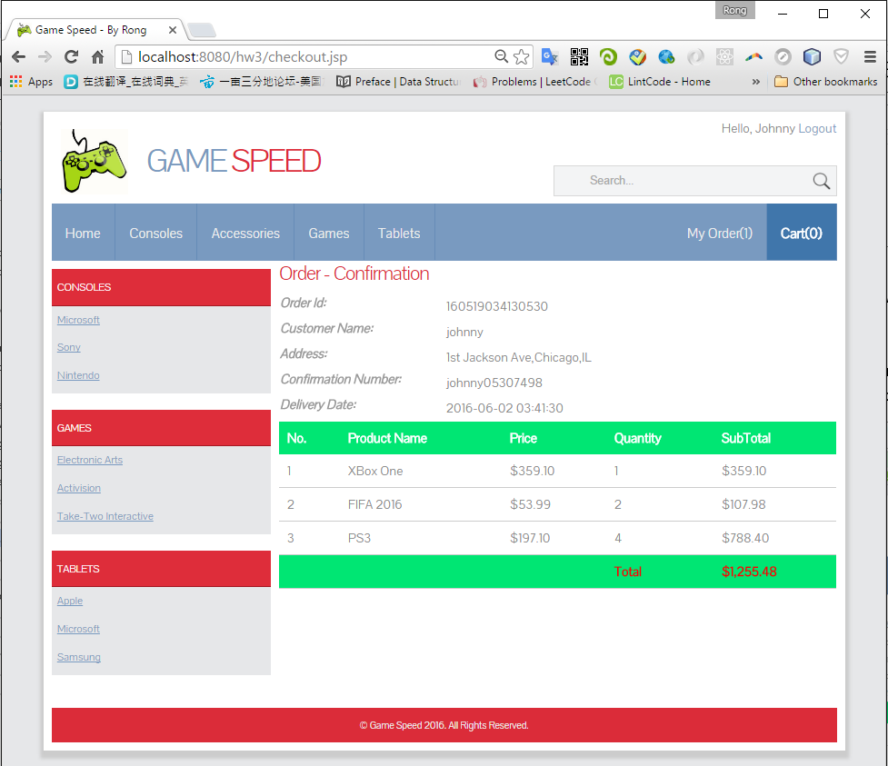

* + 1. My Order

1. Similar with the Order Confirmation page.
2. You can cancel the order when the delivery date is not within 5 days from now.

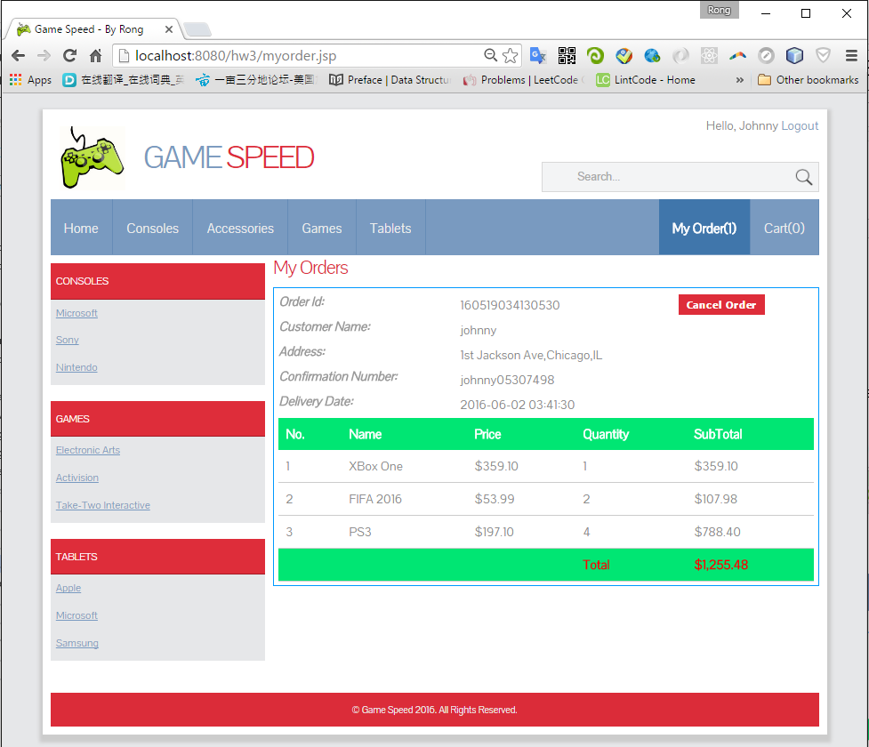

1. If there are multiple orders, all of them will be displayed, with detailed items and quantities.

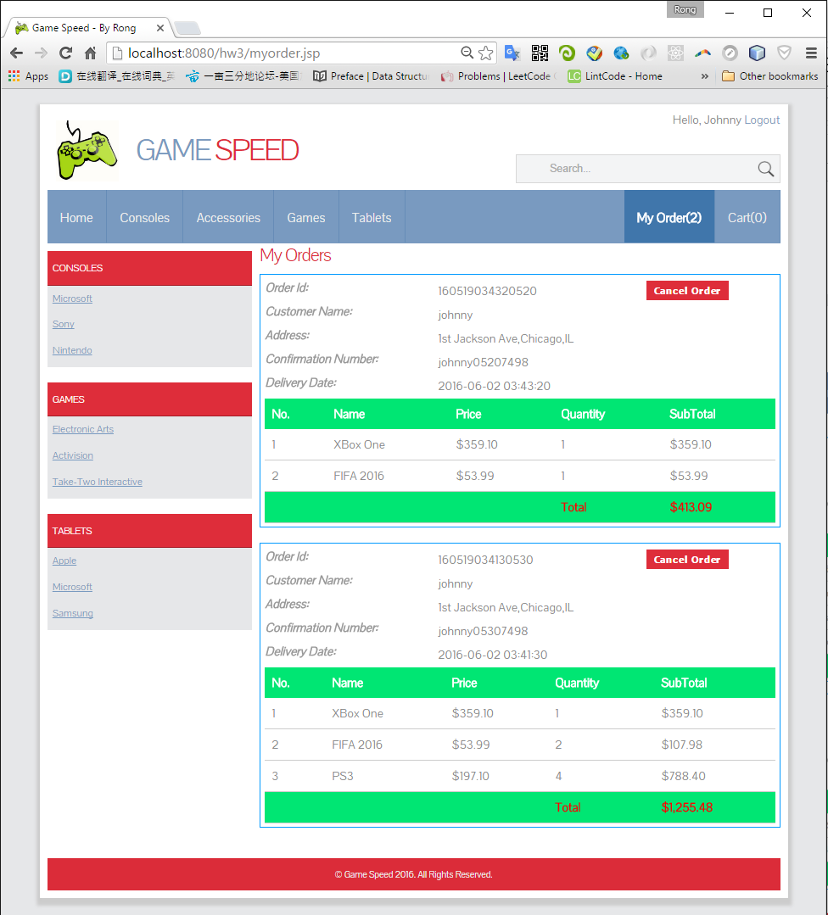

* 1. Store Manger

1. Login with the default user ‘storemanager’ and password ‘storemanager’.
2. After login, you will see two more different menu options: Accessory and Game.

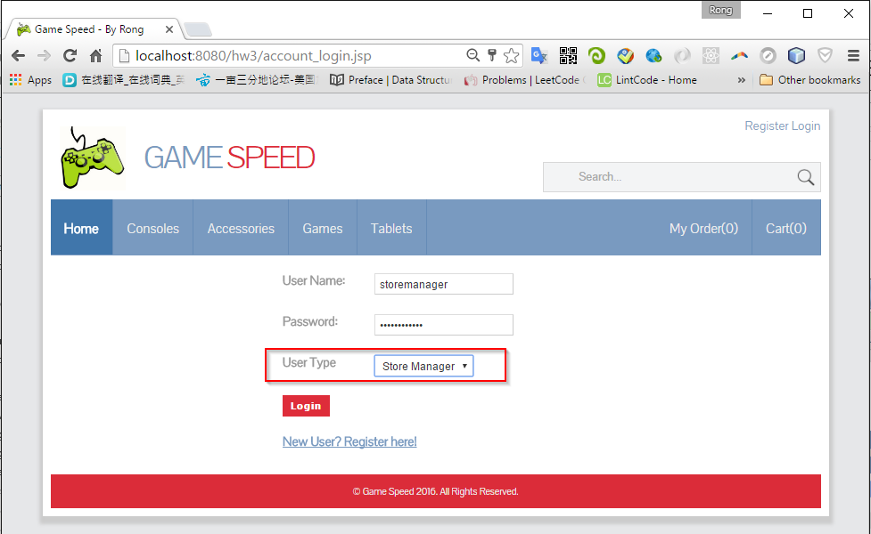

* + 1. Accessory

1. You can create, edit, and delete accessories.

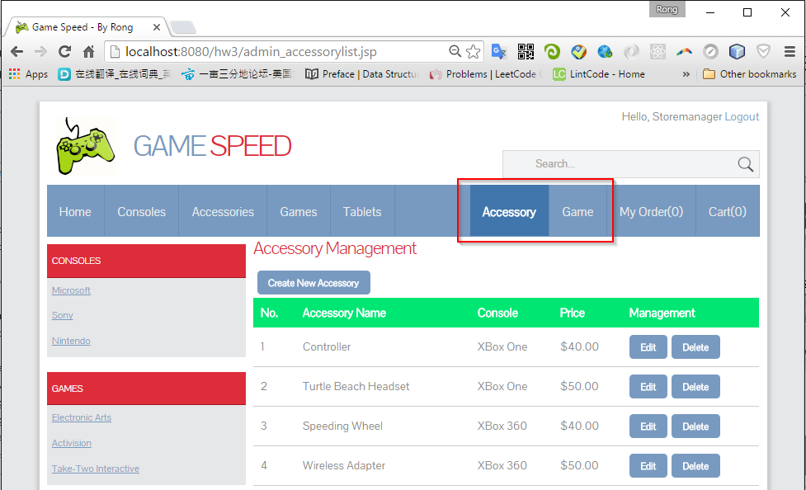

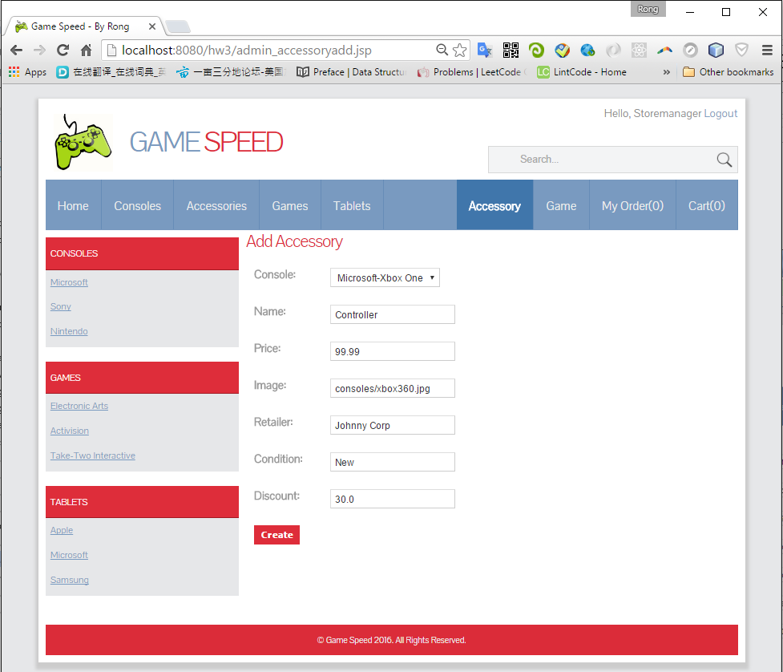

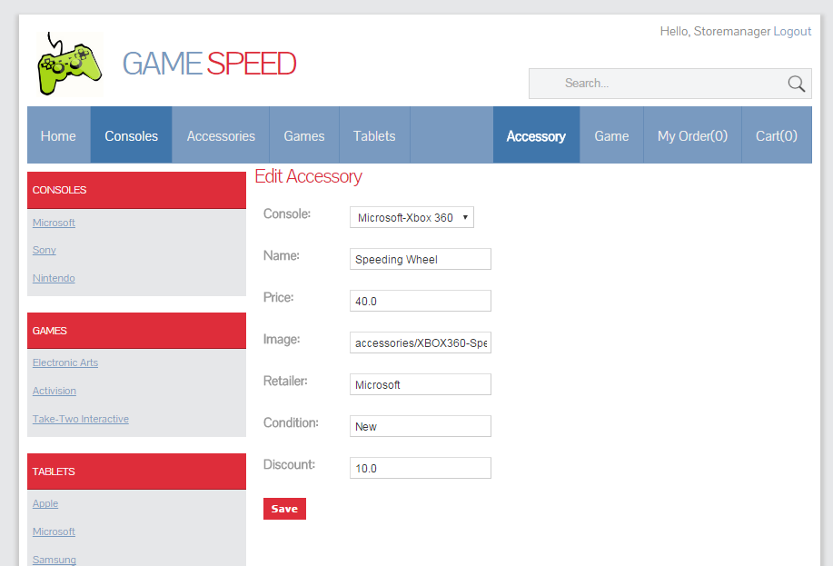

* + 1. Game

1. You can create, edit, and delete games.

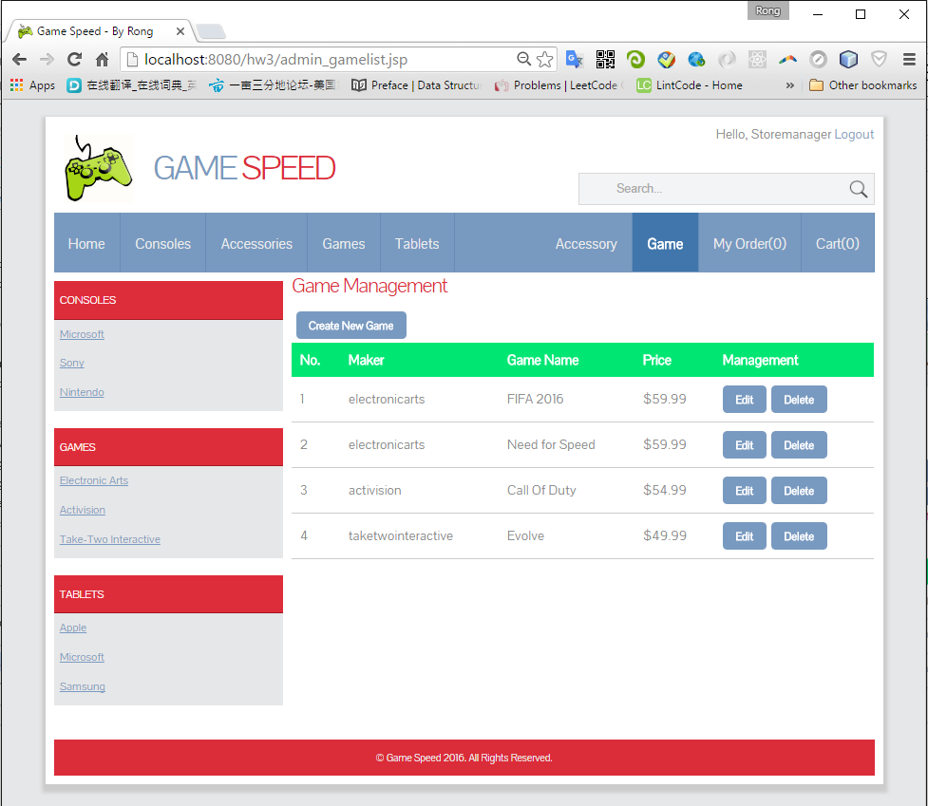

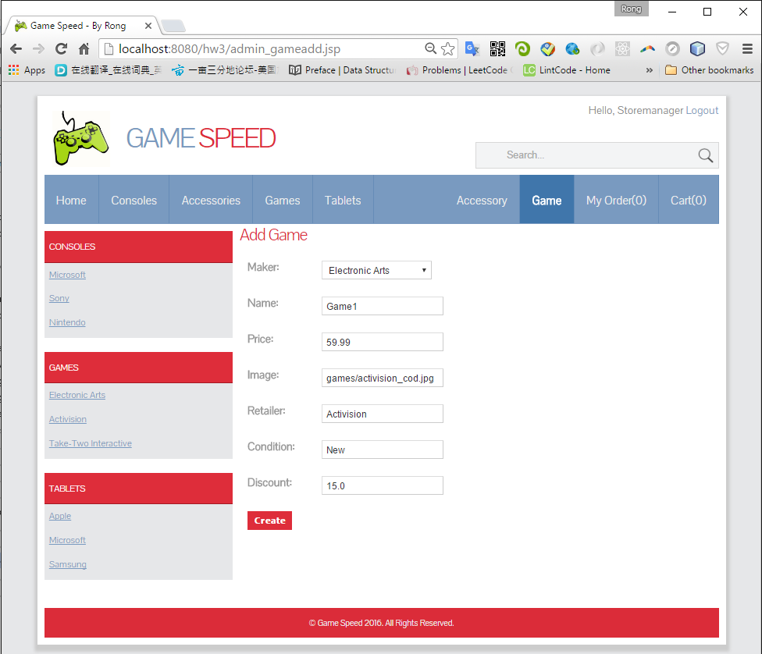

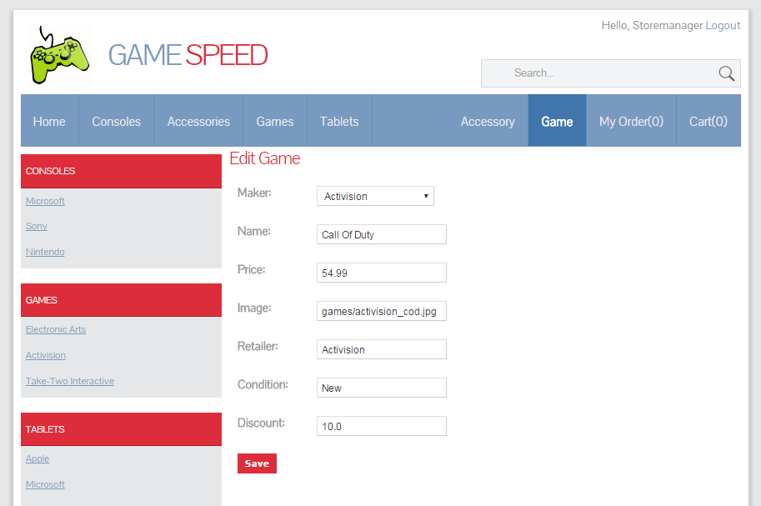

* 1. Salesman

1. Login with the default user ‘salesman’ and password ‘salesman’.
2. After login, you will see two more different menu options: All Orders and User.

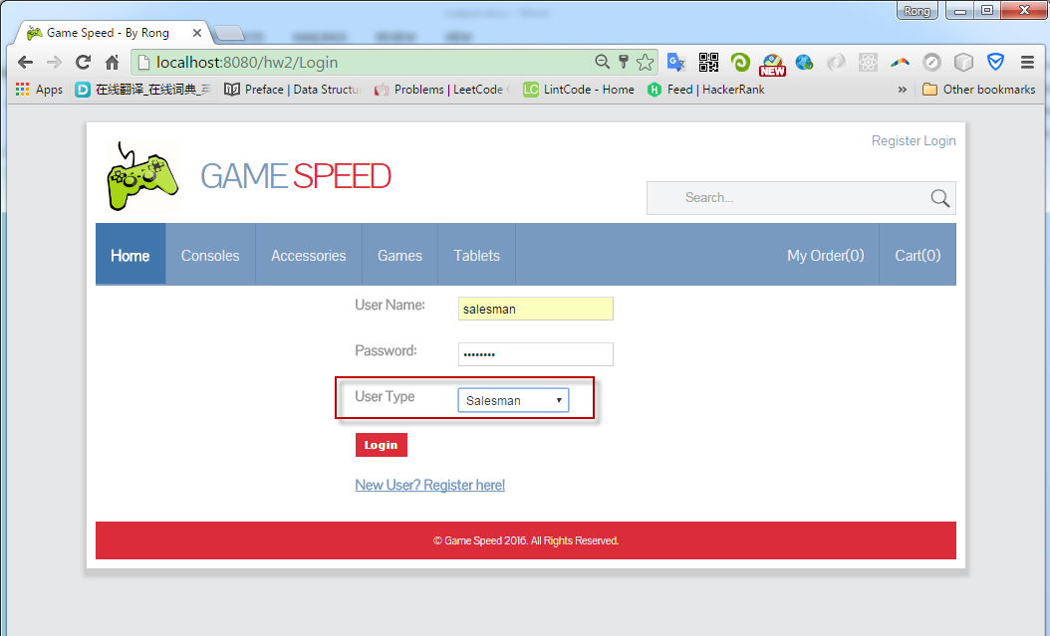

* + 1. All Orders

1. You can create, edit, and delete customers’ orders.
2. Different with ‘My Order’. ‘My Order’ only displays orders belong to current logon user. Here, it show all of the orders. ‘’All Orders’ is only authorized to ‘Salesman’.

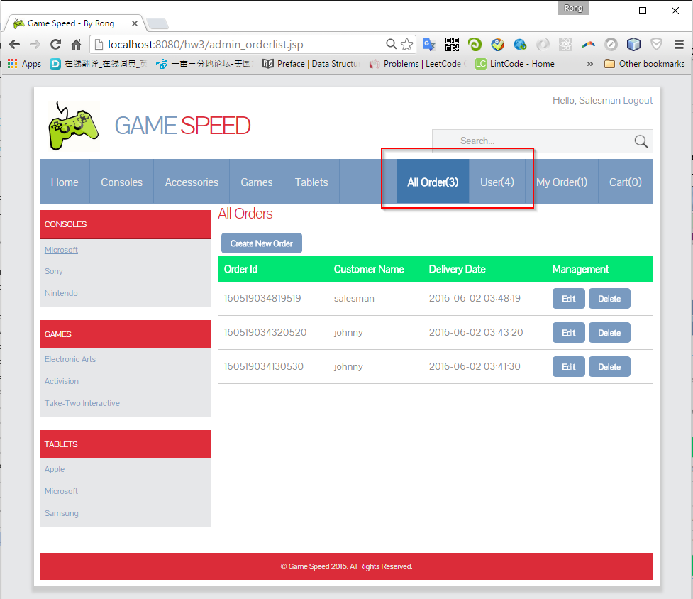

1. Create Order

Select user, provide address and credit card.

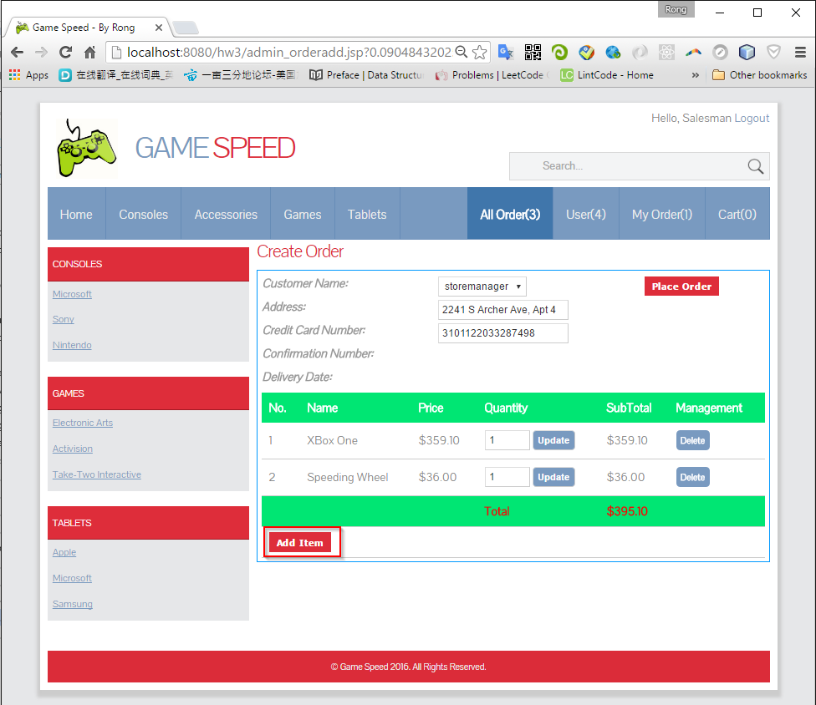

Use ‘Add Item’ to add new product to the order.

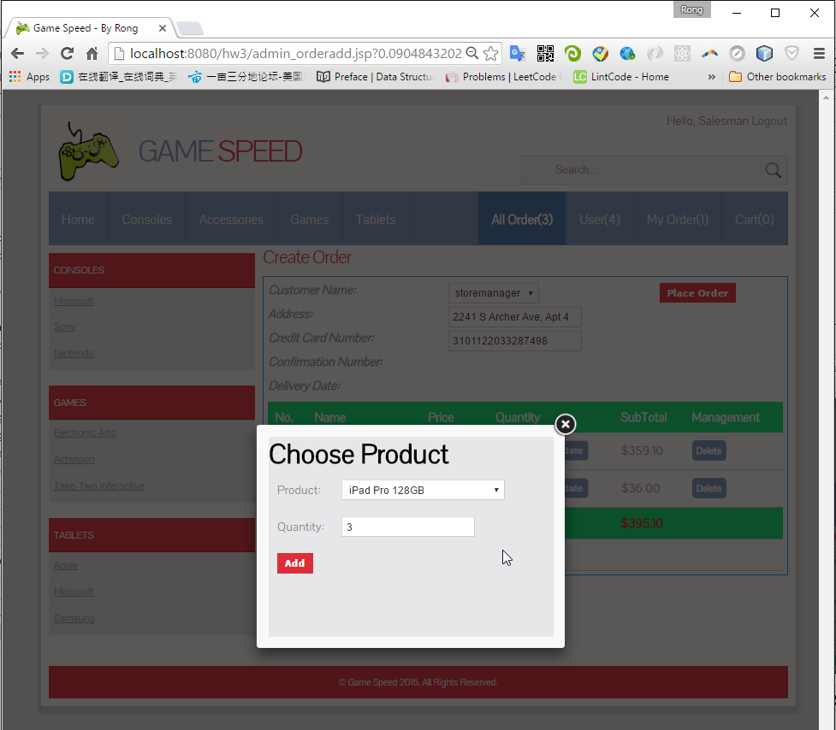

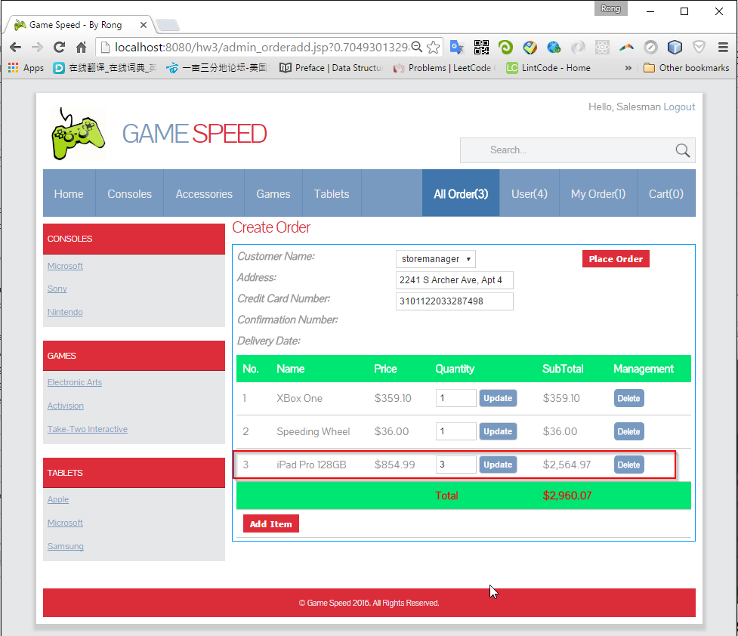

1. Edit Order

Edit address, credit card, Create new item, update quantity, delete item.

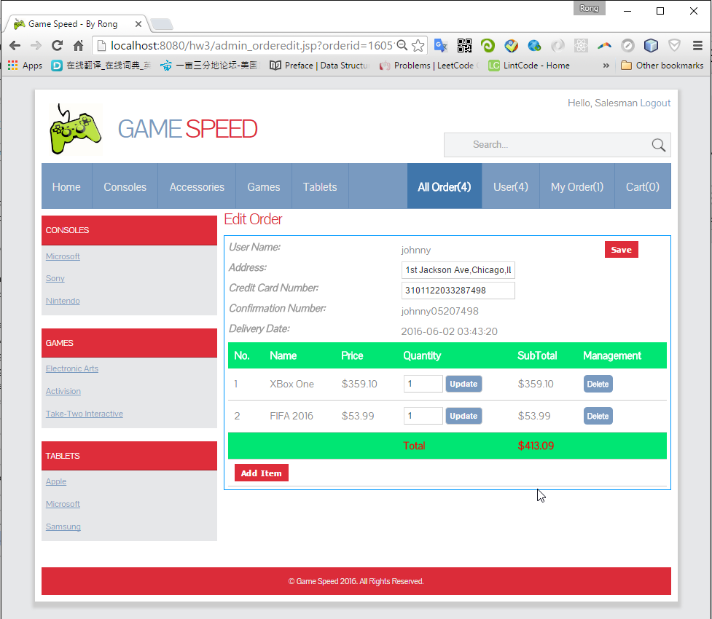

* + 1. User

1. You can create, edit, and delete users.
2. User Name must be unique, no matter what role.

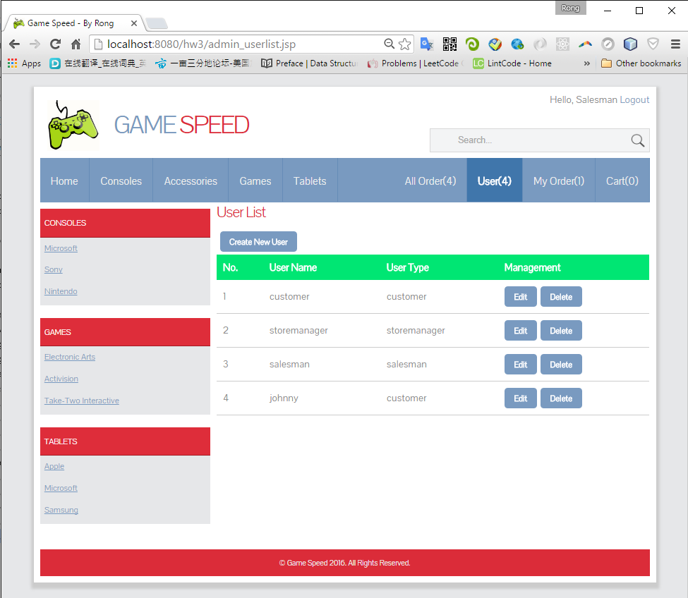

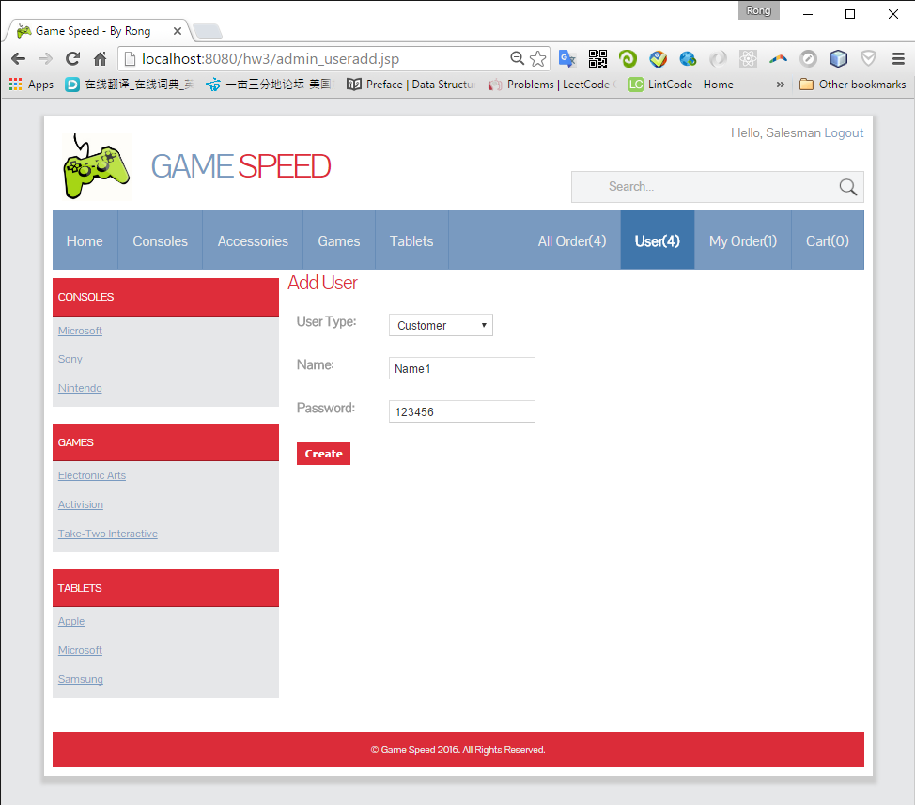

Only password is editable.

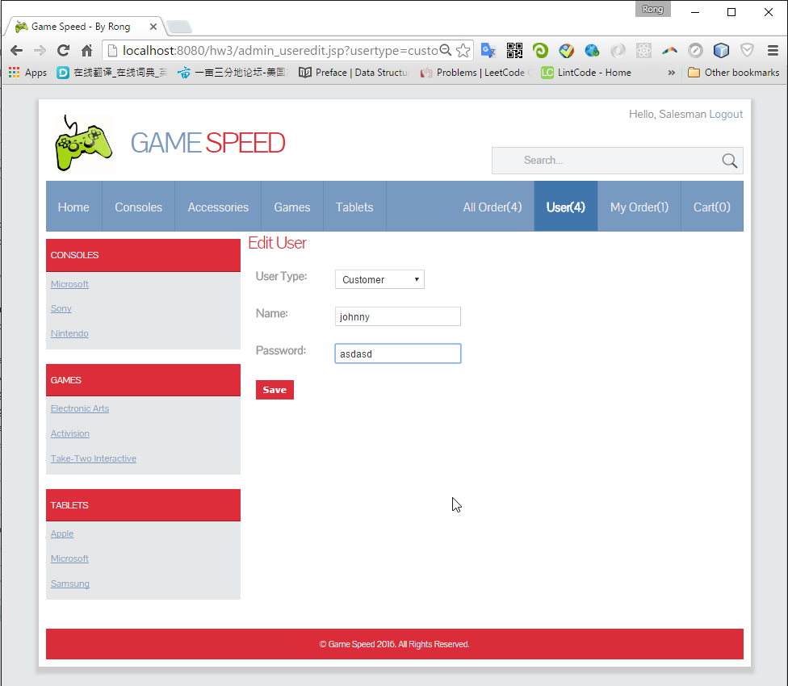

# Data Files

Products(consoles, games, tablets), Users and Orders are stored in serialized files.

